FEA STUDIO
Testing Guide
Benchmark problems with known results: workflow in the program and expected values

VERSION 1.4
CalculiX · Gmsh · NGSolve
Edition November 11, 2026

Contents
Chapters are links (Ctrl+click). The full table of contents with page numbers and sections is created when fields are updated (F9); headings are also in the Navigation Pane (View → Navigation Pane).
01 Examples and tour
02 Testing (problems with known results)

Examples and guide
Ten ready-made projects showing the program's capabilities. The guide opens them and explains step by step what is set and why.

Starting the guide
- Example 1 – printed bracket: a single PLA part; 3D printing and creep (14 steps).
- Example 2 – steel + print assembly: bolts, welds, heat, all kinds of supports and loads (12 steps).
- Example 3 – flange joint: pipe with cover, 4× M10 bolts, internal pressure 2.5 MPa, VDI 2230 (7 steps).
- Example 4 – welded boom: S355, 5 a4 fillet welds, 5000 N, weld fatigue per EN 1993-1-8 and IIW (7 steps).
- Example 5 – electronics heat sink: finned aluminium + stainless module, 40 W, convection, steady and transient heat, thermal stress (6 steps).
- Example 6 – hall frame of beams: beams without CAD, EN sections, snow and wind, natural frequencies, EN 1993-1-1 (5 steps).
- Example 7 – dynamics of a PCB fixture: point and surface mass, natural frequencies, harmonic 1 g, random vibration (ASD), probes (9 steps).
- Example 8 – crank mechanism: bodies from CAD, joints from geometry, drive, animation, reactions, transfer of the maximum instant to FEA (8 steps).
- Example 9 – bolted column base (contact): frictional contact at the bolted interface, preload, joint opening, nonlinear sequence (8 steps).
- Example 10 – bracket, topology optimization: lightening with BESO, final shape and density in 3D, STL export (7 steps).
The guide is the panel on the right: Show in app switches the program to the state the step describes, Next / Back page through the steps, Help for the step opens the detailed page. You can work freely between steps.
Tip: the guide opens a copy in %LOCALAPPDATA%\FEAStudio\ukazky; Ctrl+S does not overwrite the original.
Without the guide: Ctrl+O → examples in the installation → example1_bracket.fea to example10_bracket_topology.fea.

Example 1 – printed bracket
PLA bracket (Bambu Basic), build direction Z: a vertical plate 60×40×6 mm with two Ø5 screw holes, a horizontal arm 64×24×8 mm, and at its end a boss with an Ø8 eye (load pin) and a triangular rib.

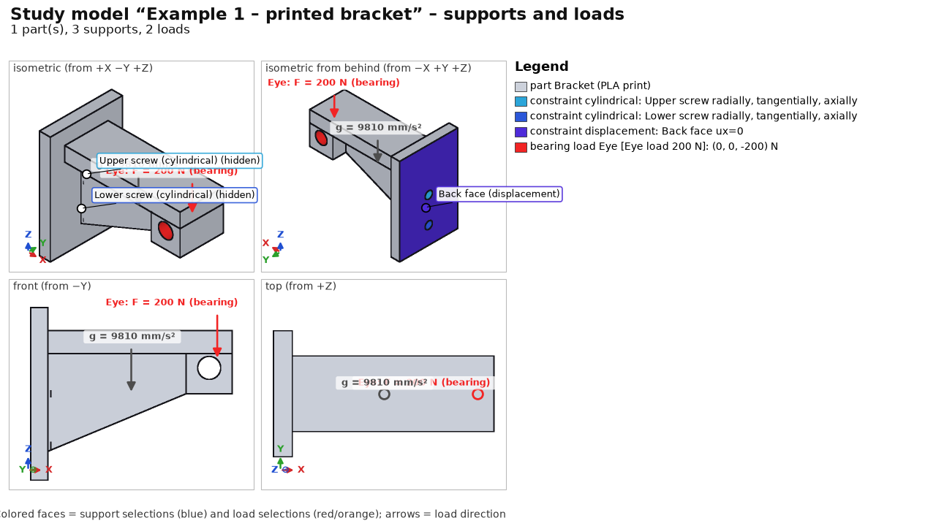
Step | Specification
Materials | Print PLA Bambu Basic (E 2680 / E_z 2160 MPa, Rm 39 / Rm_z 35 MPa)
3D printing | build Z, layer 0.2 mm, line 0.42 mm, 3 perimeters, 5/3 solid layers, gyroid 20 %; Tsai-Wu; creep 1000 h at 30 °C for the Eye load case
Supports | cylindrical support of each screw hole (Upper screw, Lower screw), back face ux = 0
Loads | Eye load 200 N (bearing load, downward); Self-weight
Mesh | 2.5 mm, tet10
Fatigue | sine 0–1 × Eye load (pulsating 0–200 N), 100 000 repetitions

Example 2 – steel + print assembly
Steel base plate 180×70×10 mm (S235) with 4 anchor holes Ø9, column 10×70×90 mm welded by two a4 fillet welds, and a printed PLA arm bolted to the plate with 2× ISO 4017 M6 x 30 - 8.8, ISO 7089 washers and ISO 4032 nuts.

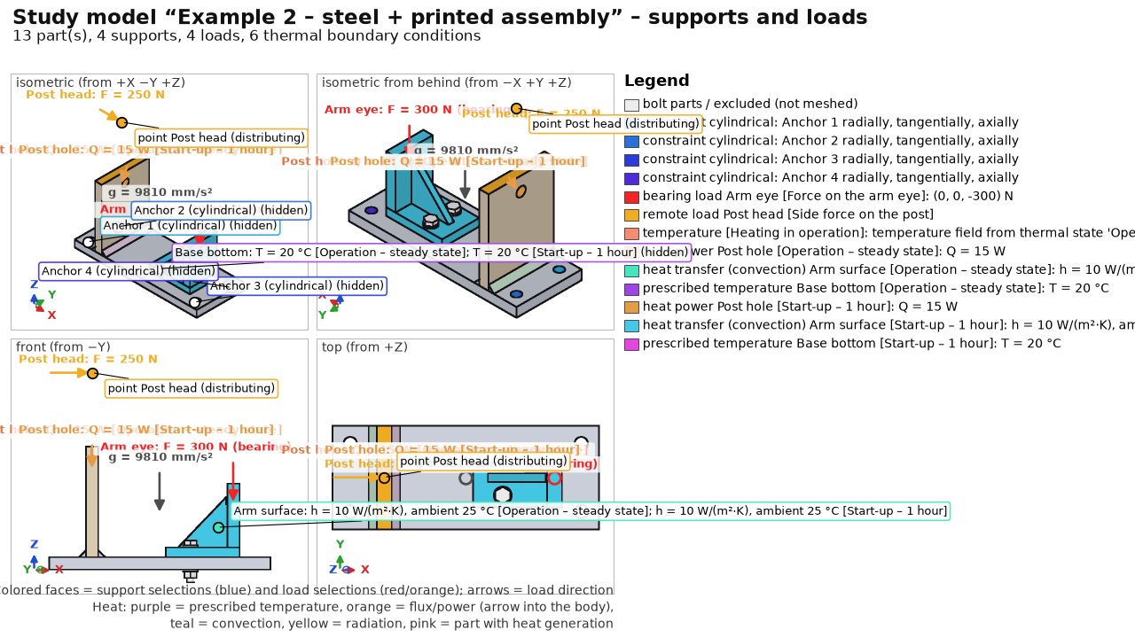
Step | Specification
Materials | Steel S235 (default), arm Print PLA Bambu Basic
3D printing | arm: 3 perimeters, gyroid 25 %, creep 2000 h / 30 °C for Force on the arm eye
Joints | 2 M6 8.8 bolts, automatic preload (Bolt preload case); 2 a4 fillet welds (EN 1993-1-8, fatigue of root and toe)
Supports | cylindrical support of the 4 anchor holes
Heat | 15 W into the column hole; arm convection 10 W/(m²·K) to 25 °C; base plate bottom 20 °C; steady state and 1 h transient ramp-up
Loads | Force on the arm eye 300 N (bearing); lateral force 250 N on the column at remote point [35; 35; 150]; Self-weight; Heating in operation (thermal stress from the steady state)
Mesh | 4 mm; local refinement of the arm eye 1.5 mm
Fatigue | two sine channels shifted by 90° (non-proportional), 200 000 repetitions

Example 3 – flange joint
Pressure pipe Ø50/36 with a welded flange Ø120 and a solid cover, connected by 4× ISO 4017 M10 × 45 8.8 bolts with washers and nuts. It verifies the preload computation and the VDI 2230 assessment.

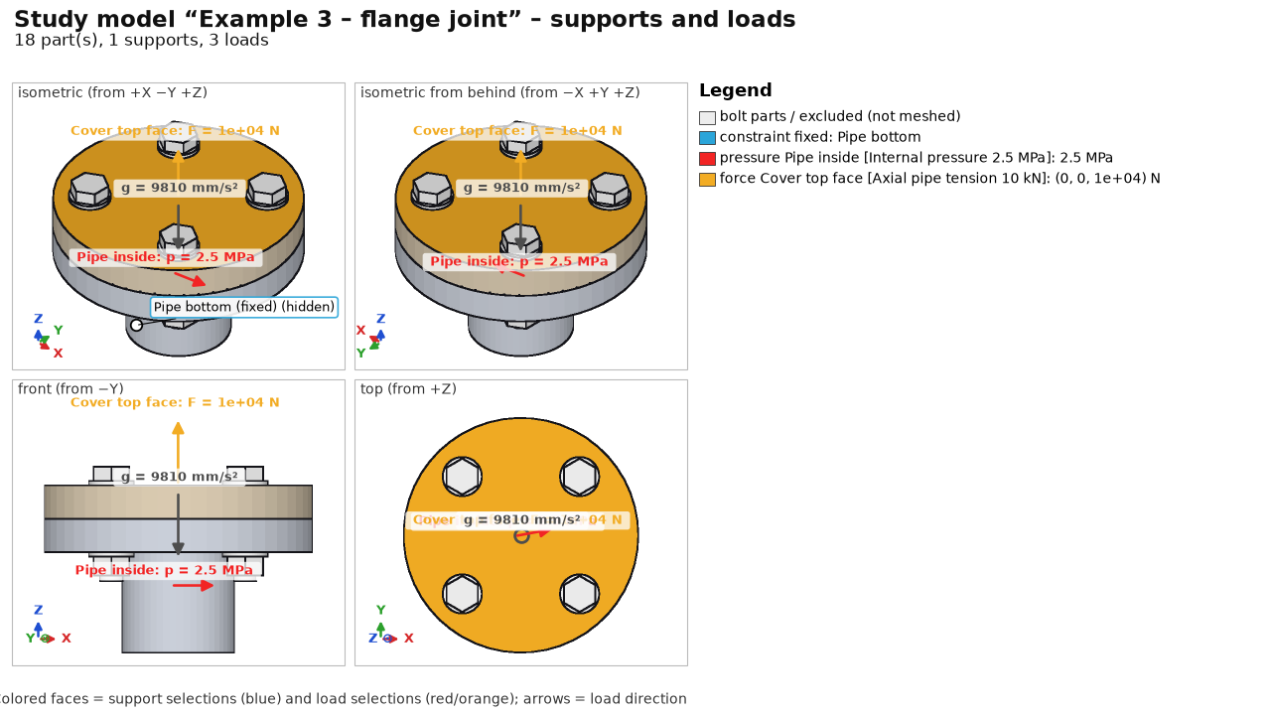
Step | Specification
Materials | Steel S355 (default for flange and cover)
Joints | 4 M10 8.8 bolts, automatic preload (tightening factor alpha_A = 1.6, friction μ = 0.12)
Supports | fixed support on the bottom end face of the pipe
Loads | internal pressure 2.5 MPa on the inner cylinder; axial tension 10 kN on the top end face of the cover; Self-weight; Bolt preload
Mesh | 5.0 mm, tet10
Assessment | VDI 2230: assembly preload, tightening torque, safety against yielding and joint opening

Example 4 – welded boom
Welded cantilever boom: anchor plate with 4 holes Ø13, horizontal arm 50×60 × 220 mm with an eye for the 5000 N load pin, triangular rib 12 mm thick and 5 a4 fillet welds.

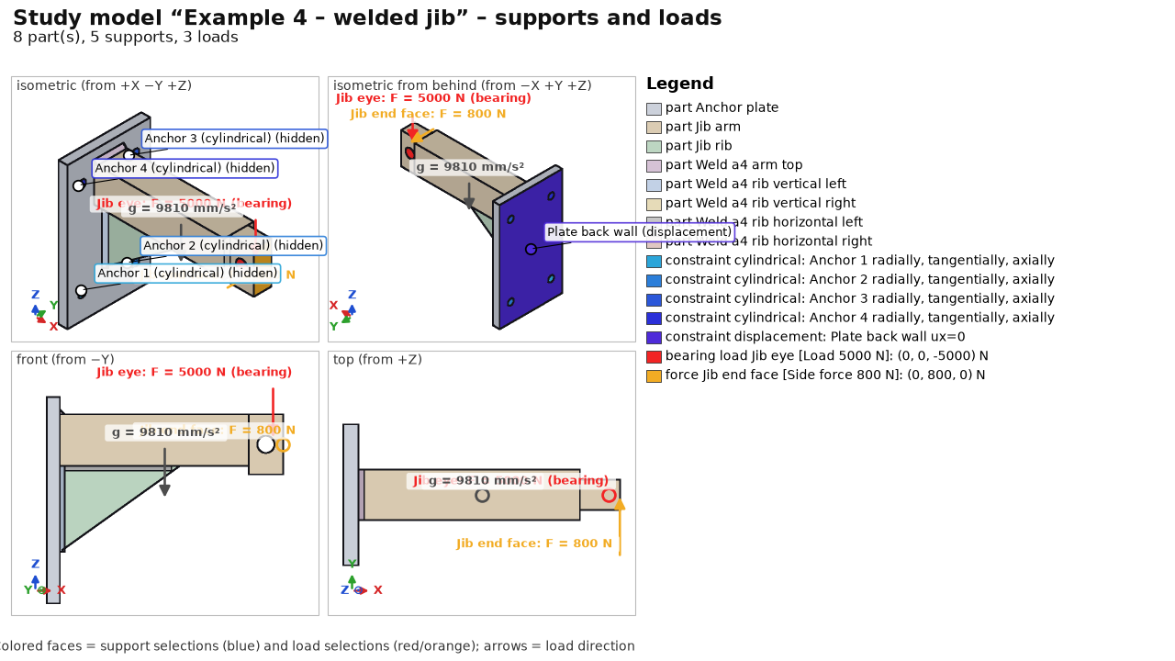
Step | Specification
Materials | Steel S355 (default)
Joints | 5 a4 fillet welds (arm to plate at the top, rib welds to the plate and arm)
Supports | cylindrical support of the 4 anchor holes; back wall of the anchor plate ux = 0 (resting against a wall)
Loads | load 5000 N in the eye (bearing load); lateral force 800 N on the arm end face; Self-weight
Mesh | 6.0 mm, tet10
Fatigue | cyclic lift 0–5 kN (200 000 cycles) shifted against the lateral force; IIW and EN 1993-1-8

Example 5 – electronics heat sink
Aluminium finned heat sink 90×80×30 mm with 6 fins and a stainless power module 30×30×4 mm dissipating 40 W.

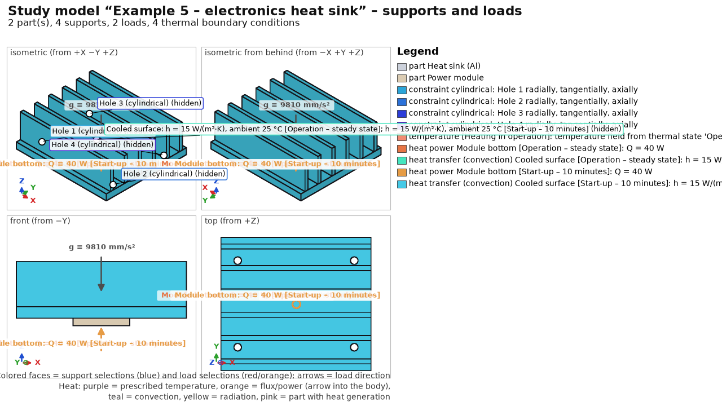
Step | Specification
Materials | Aluminium EN AW-6082 T6 (heat sink, k = 170 W/(m·K)); stainless steel 1.4301 (module, k = 15 W/(m·K))
Supports | cylindrical support of the 4 mounting holes Ø4.5 mm
Heat | 40 W into the module; natural convection h = 15 W/(m²·K) on the fins to 25 °C; steady state and 10 min transient ramp-up
Mechanics | Heating in operation (temperature field from the steady state → bimetallic bending and stress); Self-weight
Mesh | 4.0 mm, tet10

Example 6 – hall frame of beams
Steel hall made of beams only (study without STEP geometry): two frames, purlins and bracing. Results are not stored in the example; they are computed in seconds.

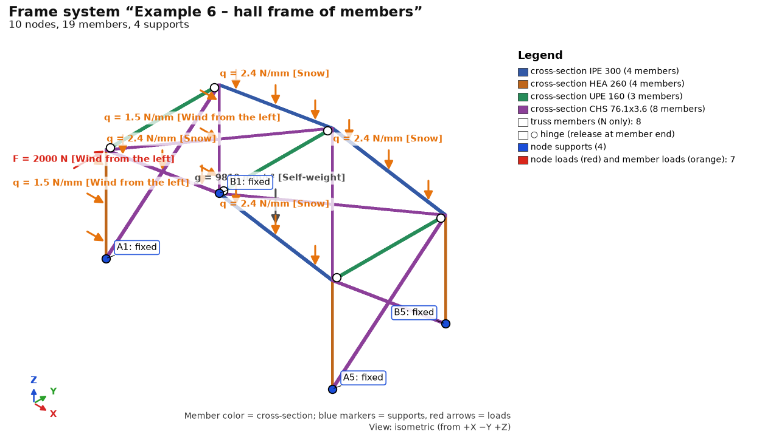
Step | Specification
Beams | columns HEA 260, rafters IPE 300 (span 12 m, gable roof), purlins UPE 160 pinned, bracing CHS 76.1×3.6 (axial only), fixed column bases; EN 1993-1-1 (column buckling lengths)
Loads | Self-weight; snow 0.8 kN/m² on rafters; wind from the left on columns + 2 kN in the gable
Solution | statics + 6 natural frequencies (1st ~4.8 Hz)

Example 7 – dynamics of a PCB fixture
Aluminium bracket clamped to a shaker table, 100×70×1.6 mm FR-4 board on 4 brass standoffs Ø6, an 80 g transformer and the board population.

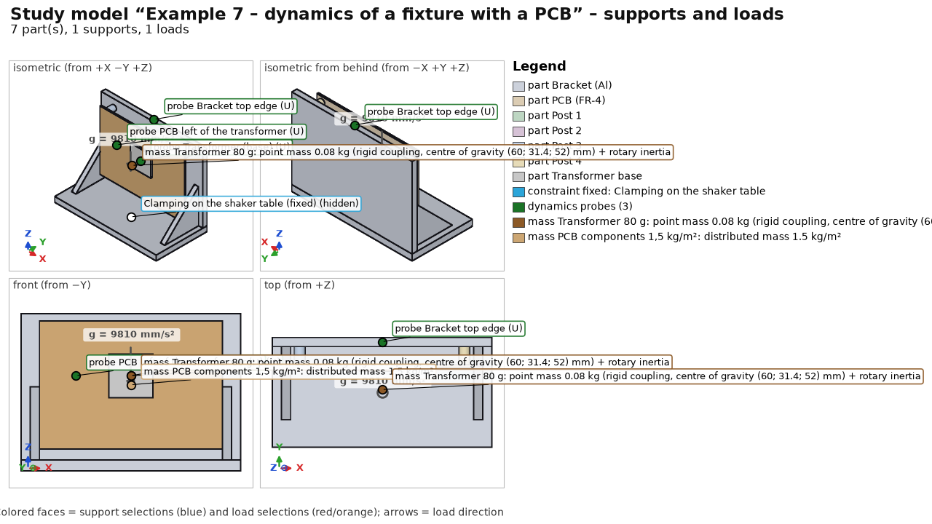
Step | Specification
Materials | Aluminium EN AW-6082 T6; brass CuZn39Pb3; custom “DPS FR-4 (orientačně)” (E 22 GPa, ρ 1,900 kg/m³)
Supports | fixed bottom face of the base (= excited base)
Dynamics | 80 g point mass with rotary inertia (rigid coupling to the footprint); 1.5 kg/m² surface mass on the board; 20 modes, ζ = 3 %; harmonic sine 1 g in Y 10–2,000 Hz; random ASD 20 Hz 0.008 → 50–500 Hz 0.02 → 2,000 Hz 0.005 g²/Hz (4.8 g_{rms}, 0.5 h, Dirlik) – an EXAMPLE in the structure of IEC 60068-2-64, not values from the standard; probes on footprint, board and bracket
Mesh | 6 mm, 3 mm at the board (local refinement), tet10, 32 k nodes; about 1 min

Example 8 – crank mechanism
Frame with a bearing and a guide; crank r = 25 mm, connecting rod l = 100 mm, piston (slider); motor 3,000 rpm, gas force 3,000 N.

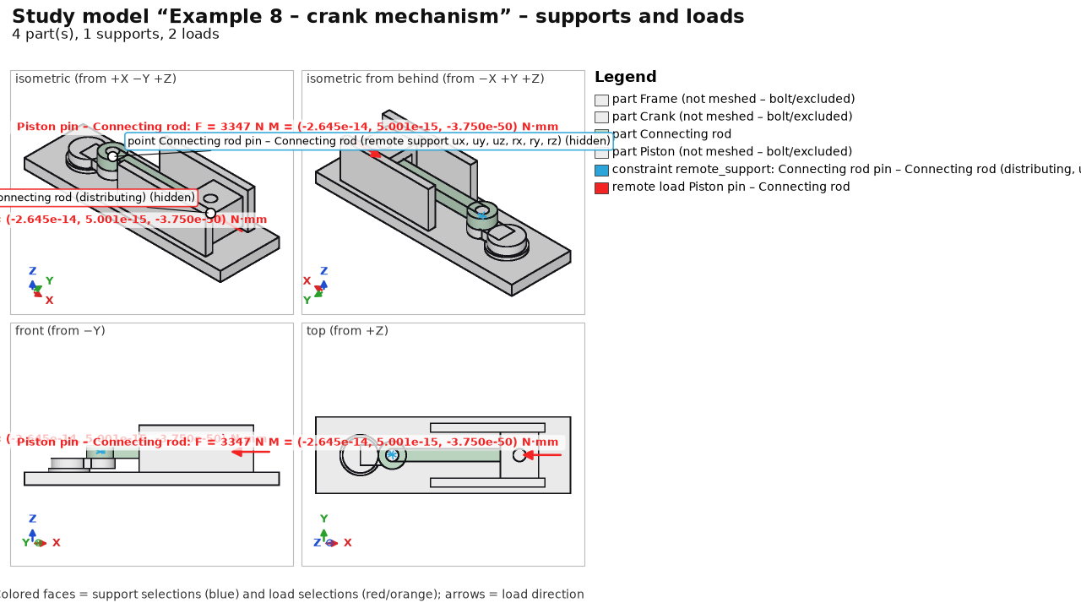
Step | Specification
Materials | Steel C45 +N (frame, crank, piston); connecting rod Steel 42CrMo4 +QT
Motion | 4 bodies (fixed frame); 3 revolute joints proposed from geometry – the rod pins changed to ball + universal (non-redundant set); sliding guide of the piston; drive at constant 314.16 rad/s; 3,000 N on the piston; gravity; kinematics of 1 revolution, 121 outputs
Transfer to FEA | instant of maximum reaction in the piston pin → load case of the rod: remote load on eye B, inertia (Inertia), eye A on a distributing remote support (inertia relief); frame, crank and piston excluded
Mesh | 2 mm, connecting rod only

Example 9 – bolted column base (contact)
Column base plate 100×60×10 with a 24×24 column on a 120×60×15 base plate, 2× ISO 4017 M10 × 45 8.8 with washers and nuts.

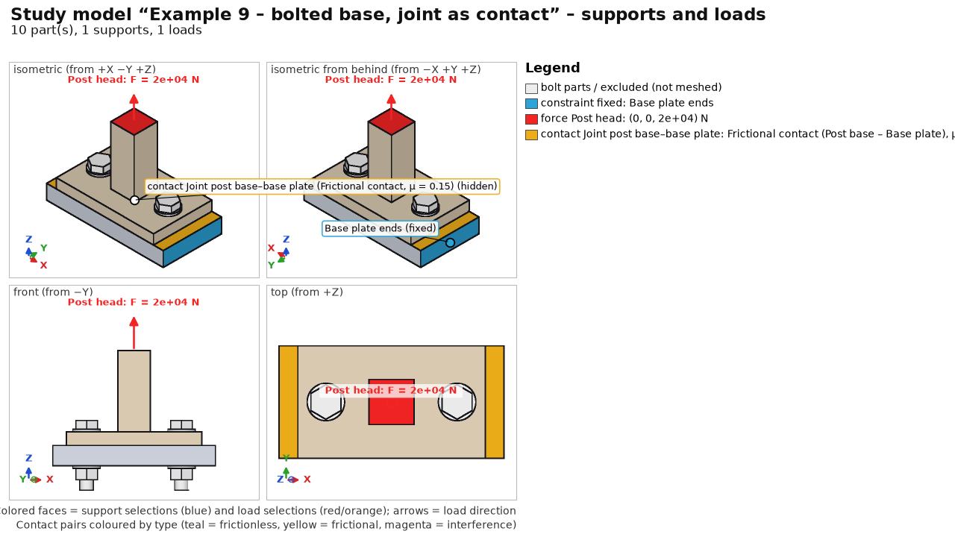
Step | Specification
Joints | 2 bolts M10 8.8, automatic preload (VDI 2230)
Contacts | bolted interfaces as frictional contact μ = μ_T = 0.15 (penalty K = 10·E); nonlinear, as a sequence: bolt preload → tension 20 kN
Supports | base plate fixed at the ends x = ±60
Loads | tension 20 kN on the top of the column (z = 70)
Mesh | 6 mm, tet10, conformal mesh with a split interface

Example 10 – bracket, topology optimization
Full steel plate 160×90×12 mm (S235) as the design space: two Ø11 holes for M10 bolts into a wall (x = 15 mm, z = 15 and 75 mm) and an Ø14 eye at the free end (x = 142 mm, z = 45 mm). Topology optimization removes lightly loaded material and keeps a shape that carries the load at the given volume.

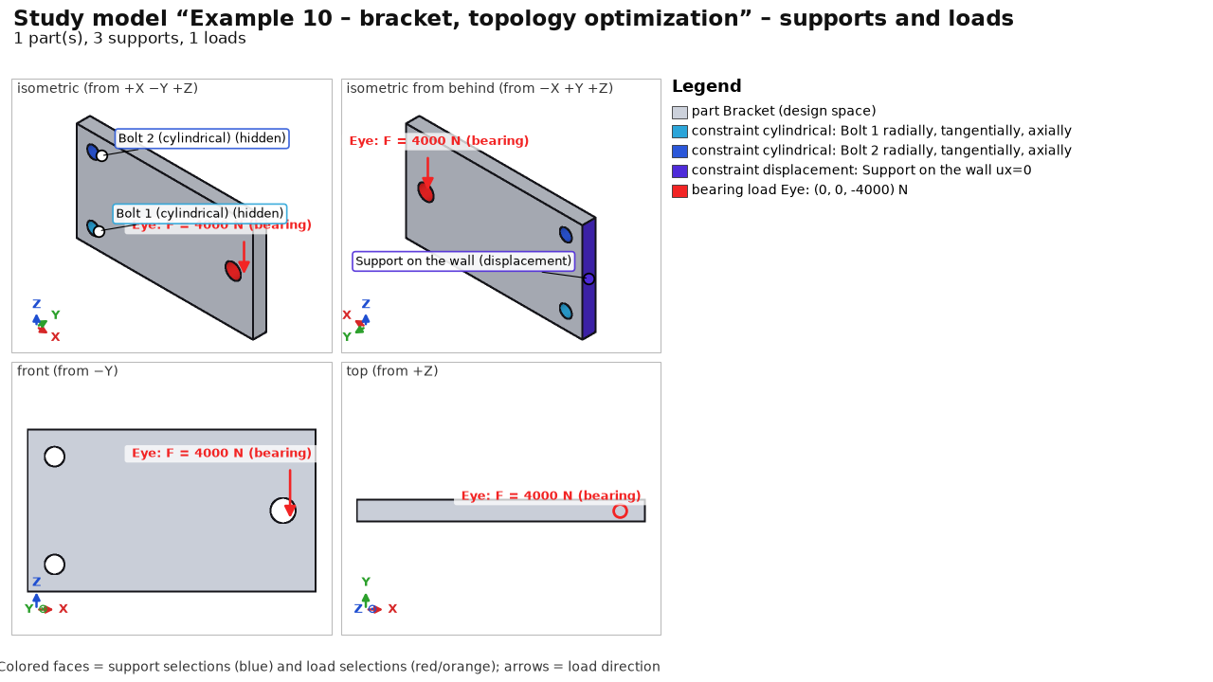
Step | Setup
Materials | Steel S235 (isotropic elastic – a requirement of topology optimization)
Supports | cylindrical support of the holes Bolt 1 and Bolt 2; face Support at wall ux = 0
Loads | case Load 4 kN – bearing load in the eye, downward
Mesh | 4 mm, tet10
Results | statics of the full design and the result (quantities Topology – density, Topology – final shape)
Topology (BESO) | target 40 % volume, filter R 8 mm, ER 4 %/step, at most 60 iterations, all selections protected (holes, eye, wall support); see Results – Topology optimization; result: 40 iterations, volume 40.0 %, compliance 2.2× the full design

Recreating the examples
A script creates the examples (geometry via OCCT in Python, the study via the program core):
.venv\Scripts\python.exe -m examples.create --solve
.venv\Scripts\python.exe -m examples.create --solve --only 8 (one example only)
.venv\Scripts\python.exe -m examples.create --solve --only 10 (example 10: topology, dozens of ccx runs)
.venv\Scripts\python.exe -m examples.frames (example 6)
Without --solve only the input is saved. examples\create.py is also a template for building studies from Python – see Automation.

Testing the program
Ten test problems with a known result (analytical solution or code-based calculation) and the example tours. Each has a procedure and a table of expected values.

Preparation
- Launch: the FEA Studio desktop shortcut or FEA Studio.bat in the program folder.
- Test models: examples\user_tests in the installation (T1_…step to T10_…step); recreate with .venv\Scripts\python.exe -m examples.user_tests.
- Guided examples: Help → Example tour (see Examples and tours).
- Verification of the whole program without the GUI (about 10 minutes): .venv\Scripts\python.exe -m verification.run_all. The output must end with VÝSLEDEK: všechny kontroly prošly (RESULT: all checks passed; the console is in Czech).
Tip: FEA values differ from analytical ones by the mesh error; each value has a tolerance. Displacements within ~3 %, stresses away from singularities within ~5 %. Larger deviations are errors – send the .fea project and a description.

Recommended order
1. Example tour 1 (printed bracket), about 1 min analysis.
2. Example tour 2 (assembly: bolts, welds, heat, fatigue), about 3 min.
3. Tests T1–T7, 5–10 minutes each.
4. Dynamics, contacts and mechanisms: example tours 7–9 and tests T8–T10.
5. Your own STEP model – follow the step bar; F1 = help.
6. Word report (Ctrl+P) and manual (Help → Example tour → Manual).

T1 – cantilever: statics, deflection and stress
Steel beam 200 × 20 × 10 mm, fixed at one end, 100 N force at the other, perpendicular to the 10 mm height.

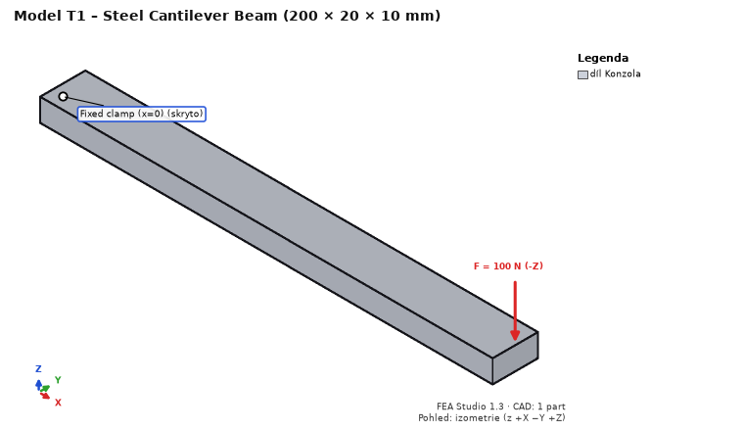
1. Ctrl+O → T1_cantilever.step.
2. Material of part Konzola: Steel S235 (E = 210 000 MPa, ν = 0.3).
3. Supports: face x = 0 → Fixed support.
4. Loads: face x = 200 → Force (0; 0; −100) N.
5. Mesh: element size 2.5 mm → Generate mesh; Solve → Run analysis.
Quantity | Expected value | Where to read
Tip deflection (displacement Z) | 0.763 mm (Timoshenko), FEA ~0.76 mm (±3 %) | Results → Displacement Z, summary
σx at mid-length, top / bottom face | +30 / −30 MPa (±5 %) | Stress σx, click at x = 100
Reaction Fz at the support | 100 N | summary – reactions
Max. von Mises | at the support, marked as singularity (support edge) | Highest stresses

Fatigue on the same model: Fatigue step → channel of the force case: sine, mean 0, amplitude 1, 1000 cycles per block, 100 blocks, signed von Mises, steel S-N: SD = 20 MPa, ND = 10⁶, k = 5, k2 = 0. At a node on the top face at x = 100: amplitude 30 MPa (±5 %), damage over 100 blocks ≈ 0.74, safety factor ≈ 1.06.

T2 – plate with a hole: stress concentration and symmetry
One eighth of a plate (width 100, thickness 5 mm, hole Ø10, tension 100 MPa): a 150 × 50 × 2.5 mm model with a quarter hole in the corner.

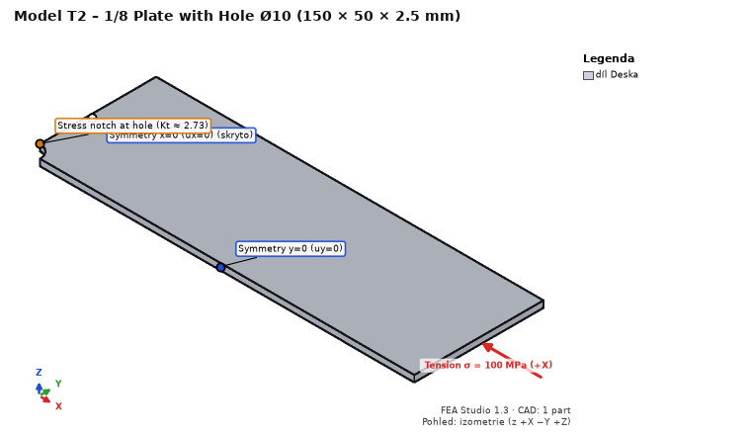
1. Open T2_plate_with_hole_eighth.step, Steel S235.
2. Symmetry supports (Prescribed displacement of one component): face x = 0 → ux = 0; face y = 0 → uy = 0; bottom face z = 0 → uz = 0.
3. Loads: end face x = 150 → Pressure −100 MPa (negative = tension).
4. Mesh 4 mm; local refinement of the hole face (Hole filter H) to 0.35 mm.
Quantity | Expected value | Where to read
σx max at the hole edge (x = 0, y = 5) | ≈ 303 MPa (Kt,n = 2.729 × 111.1 MPa, ±5 %) | Stress σx
Reaction Fx in the plane x = 0 | 12 500 N (100 MPa × 50 × 2.5) | summary – reactions
Classification of the maximum | real location (not a singularity) | Highest stresses

T3 – thick-walled tube: Lamé, heat and thermal stress
Quarter of a ring, ri = 20, ro = 40 mm, height 10 mm.

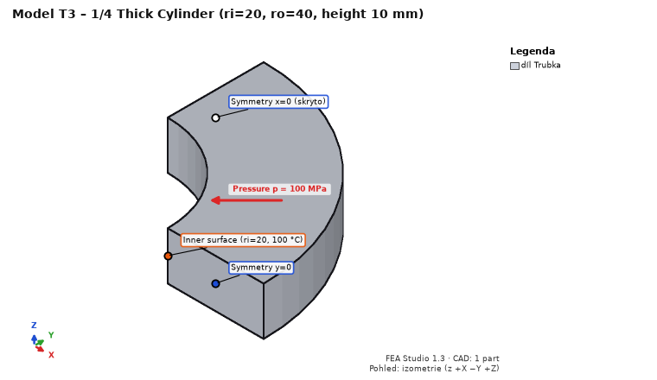
1. Open T3_pipe_quarter.step, Steel S235.
2. Supports: face x = 0 → ux = 0; face y = 0 → uy = 0; bottom face z = 0 → uz = 0.
3. Loads: inner cylindrical face (R 20) → Pressure 100 MPa. Mesh 2.5 mm; run.
Quantity | Expected value
σθ (hoop) at ri / ro | 166.7 / 66.7 MPa (±5 %)
von Mises at ri | 233.3 MPa (±5 %)
Radial displacement of the inner face | 0.01873 mm (±3 %)

Heat on the same model: Heat step → new steady-state case: inner face Temperature 100 °C, outer face (R 40) 20 °C. Results (case “Heat: …”), S235, λ = 53.3 W/(m·K):
Quantity | Expected value
Temperature at r = 30 mm | 53.2 °C (logarithmic profile)
Heat flux |q| at r = 30 mm | ≈ 205 000 W/m²
Heat through the inner face | ≈ 96.6 W (boundary condition heat table), balance within 0.1 %

T4 – shaft: torsion through a remote point
Shaft Ø20 × 200 mm, fixed at x = 0, torque 100 N·m on the other end.

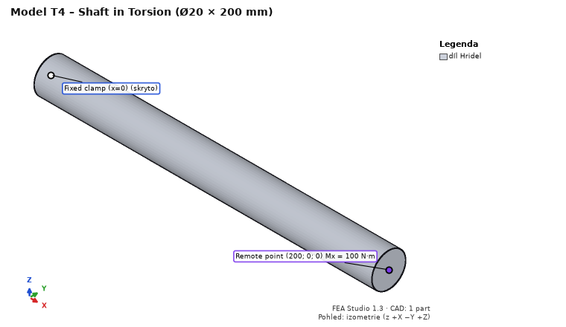
1. Open T4_shaft.step, Steel S235; fixed support on face x = 0.
2. Loads: face x = 200 → Remote force / moment, point (200; 0; 0), moment Mx = 100,000 N·mm, distributing coupling.
3. Mesh 2.5 mm; run.
Quantity | Expected value
Shear stress at the surface (τ = T/Wk) | 63.66 MPa; von Mises ≈ √3 · 63.66 = 110 MPa
Twist of the end | 0.903° (end circumference ≈ 0.158 mm)
Reaction moment at the support | 100,000 N·mm

T5 – M10 bolted joint: detection, preload, checks
Two lap-jointed 10 mm plates, ISO 4017 M10 8.8 bolt with washers and nut (names from CAD).

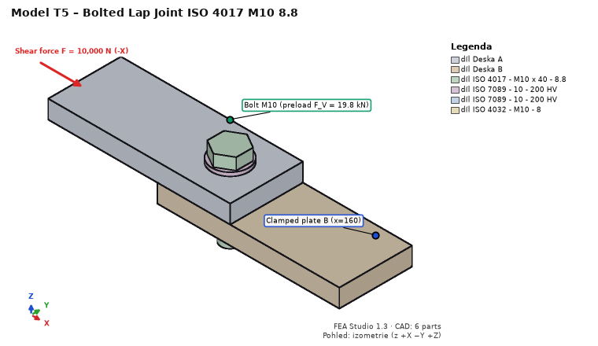
1. Open T5_joint_M10.step, plates Steel S235.
2. Joints → Detect joints… → confirm the bolt (M10 8.8, with nut, washers).
3. Supports: end face of plate B at x = 160 → Fixed support. Loads: end face of plate A at x = 0 → Force (−10,000; 0; 0) N.
4. Mesh 5 mm; run (CalculiX – other solvers do not support bolts).
Quantity | Expected value | Where
Bolt preload case – bolt force | F_V = 19 760 N | Joints – utilization dock
VDI 2230 F_M,zul (μ_G = 0.12) | 29 603 N | bolt check
EN 1993-1-8 F_v,Rd (shear in thread) | 22 268 N | bolt check
EN 1993-1-8 F_b,Rd (bearing, e1 = e2 = 20) | 43 636 N | bolt check
Shear through interface + bolt | 10,000 N | joint forces

T6 – T-joint with a5 fillet welds
Flange 10 mm, web 10 × 100 mm, two a5 fillet welds of length 100 mm (bodies “Svar …”).

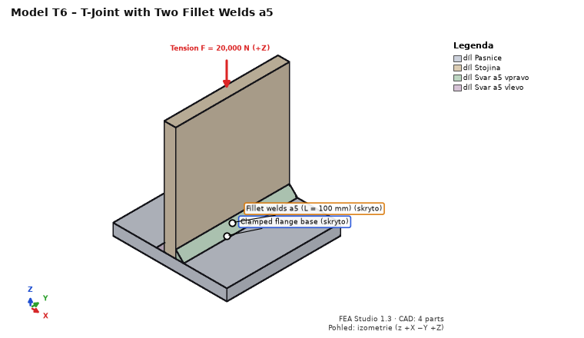
1. Open T6_t_joint_welds_a5.step, Steel S235. Joints → Detect joints… → confirm 2 welds.
2. Supports: bottom face of the flange (z = −10) → Fixed support.
3. Two load cases: “Tah” (tension): top face of the web (z = 100) → Force (0; 0; 20,000) N; “Podélný smyk” (longitudinal shear): same face → Remote force at (0; 50; 0), force (0; 10,000; 0) N.
4. Mesh 5 mm; run.
Quantity | Expected value
Effective throat a / weld length from the mesh | 5.0 mm / 100 mm
Tension: sum of segment forces of both welds | 20,000 N
Longitudinal shear: mean τ∥ = F / (2·a·L) | 10 MPa

T7 – 3D printing: orthotropy by build direction
Two 100 × 10 × 10 mm PLA bars: one printed upright (layers perpendicular to the length), the other lying flat.

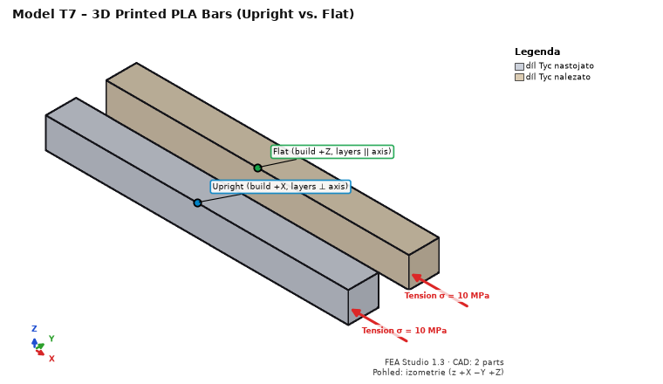
1. Open T7_printed_bars.step. Material of both parts Print PLA Bambu Basic.
2. 3D printing: part “Tyc nastojato” (upright) – build direction +X; “Tyc nalezato” (flat) – +Z; for both turn off “shell + infill” (whole part solid) → Apply to selected parts. Failure criterion Tsai-Hill.
3. Supports: end faces x = 0 → ux = 0; side faces y = 0 and y = 20 → uy = 0; bottom faces z = 0 → uz = 0.
4. Loads: both end faces x = 100 → Pressure −10 MPa. Mesh 3 mm; run.
Quantity | Expected value
Elongation of the upright bar (perpendicular to layers) | σL/E_z = 0.4630 mm
Elongation of the flat bar (in the layer plane) | σL/E_xy = 0.3731 mm
Safety factor (Tsai-Hill) | upright 3.50 (Rm_z/σ), flat 3.90 (Rm/σ)
Reaction Fx | 2,000 N

Then turn on “shell + infill” (3 perimeters, infill 20 %): stiffness and safety both drop; the Shell / core section shows the solid shell share.

T8 – cantilever: natural frequencies and harmonic response
Steel beam 100 × 10 × 10 mm fixed at one end, harmonic force 100 N at the free end (verification Y2).

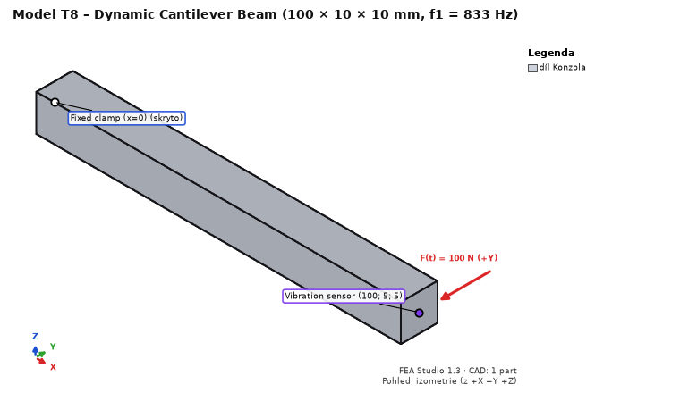
1. Open T8_cantilever_10x10x100.step, Steel S235.
2. Supports: face x = 0 → Fixed support. Loads: face x = 100 → Force (0; 100; 0) N, load case named “Síla Y 100 N”.
3. Step Dynamics: compute dynamics, 10 modes; modal damping ζ = 2 %; compute harmonic response, 10–2 000 Hz; excitation force – load case Síla Y 100 N (Add excitation); probe at (100; 5; 5).
4. Mesh 2.5 mm; run (about 20 s).
Quantity | Expected value | Where to read
1st and 2nd natural frequency (bending in y and z) | 833 Hz (Euler–Bernoulli 835.5 Hz, Timoshenko 0.3 % lower; ±1 %) | Dynamics – table of modes
Sum of effective masses of both modes in y | 61 % (E–B 61.3 %); a square section may split it between the two modes | table of modes
3rd and 4th mode (2nd bending), 5th (torsion), 6th (axial) | ≈ 5,000 Hz (E–B 5,236 Hz), ≈ 7,390 Hz, ≈ 12,970 Hz | table of modes
Static tip deflection (Síla Y 100 N) | 0.190 mm (E–B FL³/3EI = 0.1905 mm) | Displacement Y, summary
Peak |u_{y}| at the probe (resonance) | 4.62 mm = 24.2 × static (E–B 0.9707/(2ζ) = 24.27; ±2 %) | Dynamics – FRF plot, probe
|u_{y}| at 10 Hz | 0.190 mm (quasi-static) | FRF plot

With ζ = 1 % the peak doubles (resonance response ∝ 1/damping).

T9 – contact of two blocks: contact pressure
Two steel blocks 20 × 20 × 10 mm stacked, 10 MPa on the top face, frictionless contact (verification K1, “patch test”).

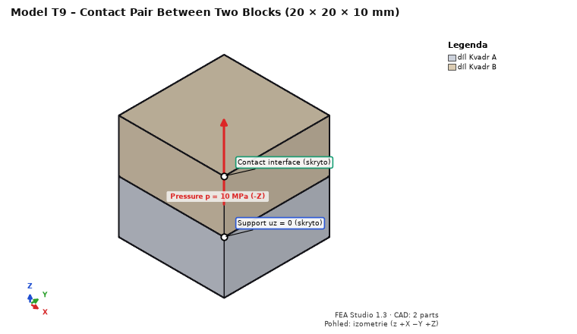
1. Open T9_contact_blocks.step, Steel S235.
2. Supports (sliding): bottom face z = 0 → uz = 0; faces x = 0 (both blocks) → ux = 0; faces y = 0 → uy = 0.
3. Loads: top face z = 20 → Pressure 10 MPa.
4. Step Contacts: Find touching parts → pair Kvadr A – Kvadr B, Frictionless contact → Add. The analysis is nonlinear (CalculiX).
5. Mesh 2.5 mm; run (about 20 s).
Quantity | Expected value | Where to read
Contact – pressure | 10.0 MPa uniform (±0.5 %) | Contact – pressure
Normal force of the pair | 4,000 N (10 MPa × 400 mm²) | Contacts tab
Displacement of the top face | −0.000953 mm (2ph/E + p/K, K = 50·E) | Displacement Z
Contact – opening, status | 0 mm, whole face in contact | contact quantities

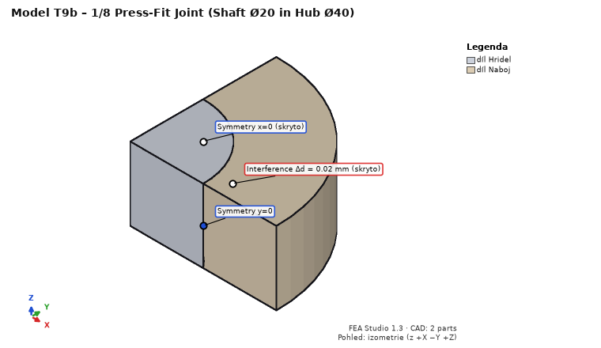
T9b – press fit (T9b_press_fit_eighth.step, K4): one eighth of a Ø20 shaft in a Ø20/40 hub, length 2 × 10 mm. Symmetry supports x = 0 → ux = 0, y = 0 → uy = 0, z = 0 → uz = 0. Empty load case “Lis”. Contacts: pair Hridel – Naboj, Interference (press fit), interference −0.01 mm (Δd = 0.02 mm). Mesh 1.25 mm (about 1 min). Expected (Lamé): contact pressure 78.75 MPa (FEA mean ~80 MPa), hub hoop stress at the bore 131.3 MPa, radial displacement of the hub bore +7.4 µm, of the shaft −2.6 µm.

T10 – crank mechanism: kinematics and drive torque
Crank r = 20 mm, connecting rod l = 80 mm, piston; crank at 100 rad/s; 1,000 N on the piston against the X direction (verification MB1).

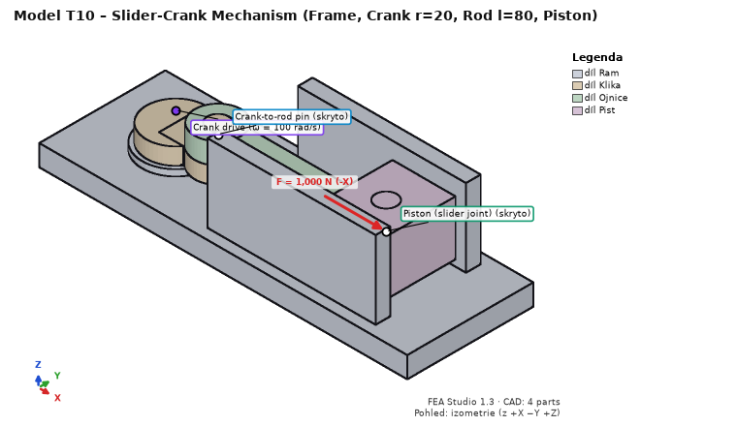
1. Open T10_crank_r20_l80.step, Steel S235 for all parts.
2. Step Motion, tab Bodies: Body for each part (the first part Ram = frame).
3. Tab Joints: Suggest from geometry → accept 3 revolute joints (frame–crank, crank–rod, rod–piston). Add a Slider frame – piston, origin (100; 0; 13), axis (1; 0; 0).
4. Tab Drivers and forces: driver of frame–crank, angular velocity 100 rad/s; load on body Pist, force (−1,000; 0; 0) N at (100; 0; 13); gravity off.
5. Tab Analysis: kinematic, 0.0628319 s (one revolution), 360 outputs → DOF check (0 DOF with drivers, 3 redundant constraints) → Run motion.
Quantity at t = 0.010472 s (crank at 60°) | Expected value
Piston position x (centre of mass = pin axis) | 88.102 mm (r·cos φ + √(l² − r²·sin² φ))
Piston velocity v_{x} | −1,953.8 mm/s
Piston acceleration a_{x} | −75,022 mm/s²
Drive torque without inertia (set mass 0.001 kg and zero inertia manually) | |M| = F·|v|/ω = 19,538 N·mm
Drive torque with CAD mass (steel) | |M| ≈ 19,250 N·mm (inertia of rod and piston)
Body equilibrium, power balance | ≈ 0 (motion result summary)

The sign of velocity and torque depends on the crank joint axis (+z = counter-clockwise seen from above). Then try Transfer to FEA… for the connecting rod (instant of maximum pin reaction), as in example 8.

What else to try
- Solvers: Solve → Solver section: CalculiX / NGSolve + PARDISO / NGSolve + hypre; T1 displacement must agree to 4 significant digits. NGSolve solvers come with the Full profile (modules ngsolve, hypre, and on Windows Microsoft MPI); in the standard install they are greyed out (“not installed”) – install with Install solvers… (Tools → Program modules…) and restart, or skip.
- Undo / Redo (Ctrl+Z / Ctrl+Y); save Ctrl+S and reopen (results are saved with the project).
- Word report (Ctrl+P) – compare the numbers with the tables.
- Section in results (top bar: Section → axis and slider) and a probe by clicking into the model.
- Automation: command line, MCP, REST, e.g. python -m fea_core run study.json.

Reporting bugs
Send the saved .fea project (Ctrl+S), the text of the Solver log dock (Ctrl+A, Ctrl+C), what you expected and what happened; for a crash also the command-line window contents, if open.

